Title

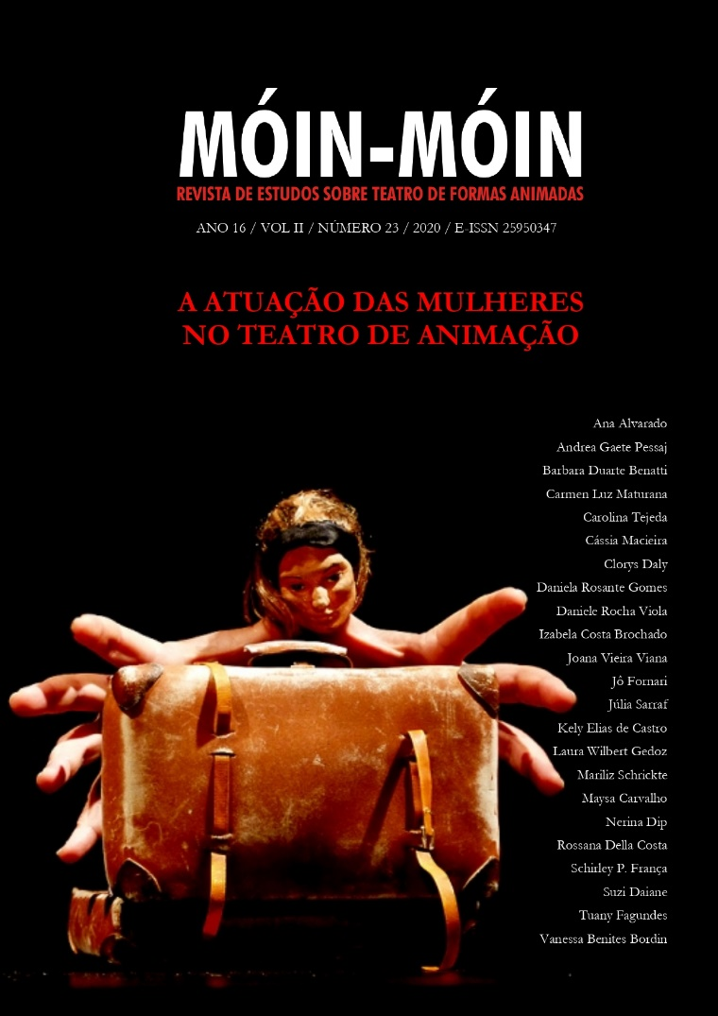

Figure 1 – Example of initial image: Cover of Móin-Móin nº 23. With Picture of the show Desde el azur, by Inés Pasic. Photo: Jesús Atienza

Title

Abstract: The file must present, in font size 10 and single spacing, the abstract (between 400 and 700 characters) and up to five keywords; English title, abstract and up to five keywords (with the same dimensions). The words “Abstract”, “Keywords”, and the title must be in bold. Keywords must be separated by a semicolon and only the first letter capitalized.

Keywords: Keyword 1; Keyword 2; Keyword 3; Keyword 4; Keyword 5.

Título em português

Resumo: O arquivo deve apresentar, em fonte tamanho 10, espaçamento simples e margem justificada, o resumo, (entre 400 e 700 caracteres) e até cinco palavras-chave; título em inglês, abstract e até cinco keywords (com as mesmas dimensões). As palavras “Resumo”, “Palavras-chave”, “Abstract” e “Keywords” e o título em inglês devem estar em negrito. Palavras-chave e keywords devem ser separadas por ponto e vírgula e apenas a primeira letra em maiúsculo.

Palavras-chave: Palavra 1; Palavra 2; Palavra 3; Palavra 4; Palavra 5.

III – Rules for the submission of articles, reports, translations and interviews
The texts must be sent to the OJS platform of the Periodical’s Portal of UDESC (http: //www.http: //revistas.udesc.br/index.php/moin) in which the data of the authors must be inserted only in the system’s form , including the email address and biography of up to five lines, emphasizing the institutional link and academic and artistic backgrounds. The file with the article and report must be free of any type of identification, either by the name of the authors typed in the body of the text or in the file properties, or by mentioning information through which the authorship can be deduced. If you have difficulties making the article anonymous, just mention it in the "comments to the editor" during the online submission process. The Editorial will respond to the sender, confirming the receipt of the file.
The papers must be submitted rigorously revised, in accordance with current grammatical rules. Texts must be submitted according to the template provided by the Magazine, authors must download the template and adapt their texts to this format.
The articles published by the magazine are of free use, intended for educational and non-commercial applications. Copyrights are all assigned to the magazine.
All contribution proposals must be in Microsoft Word text editor (DOC format) or compatible, with font Arial size 12 and 1.5 space. Title in bold, and lowercase. New paragraph in measure “1.25”, all paragraphs together unless there is a heading for each paragraph (headline paragraph).
The articles, reports, translations and interviews can be between 8 (eight) and 15 (fifteen) pages and the file must be limited to 8 MB.
The file must have the title, font size 14 (maximum 100 characters).
The file must present, in font size 10 and single spacing, the abstract (between 400 and 700 characters) and up to five keywords; English title, abstract and up to five keywords (with the same dimensions). The words “Abstract”, “Keywords”, and the title must be in bold. Keywords must be separated by a semicolon and only the first letter capitalized.
Notes should be placed as a footnote, Times New Roman, size 10, single spacing and justified margin.
Citations of up to three lines must be enclosed in quotation marks and in the body of the text.

Citations with more than three lines should be highlighted, in font size 10, single spaced, without quotes and without italics, with indentation to the left of 4 cm. Interventions made in citations (introduction of terms and explanations) must be enclosed in square brackets. Omissions of excerpts from the quotation must be marked by an ellipsis in parentheses.

The terms in languages different from the language of the text must be written in italics.
The insertion of citations, in the article, in non-Portuguese or Spanish language, must appear in the body of the text in Portuguese and in a footnote the text in the original language, plus the name of the translator.
References: should only refer to the texts cited in the paper and be at the end of the text. The word References must be in lowercase, bold, Arial, size 12.
References must use the author/date system as follows: (AUTHOR'S SURNAME, year) for indirect citations and (AUTHOR'S SURNAME, year, page) for direct citations. Examples: (SILVA, 1997) or (SILVA, 1997, p.452). Different titles by the same author and the same year must be identified with a letter that differentiates them. Example: (SILVA, 1997a, p.452). References must be in Arial, size 10, single spaced and left margin.
Submissions are recommended to include photos, drawings or graphic materials (by the author or third parties). It is essential to indicate the source or authorship of the image in the caption. Photos / images must be of good quality and must be submitted with at least 300 dpi.
The submission of the original article implies in the authorization for publication according to the Creative Commons 4.0 concept and will be published in the digital Móin-Móin magazine.
The magazine does not accept contributions that have been submitted to more than one journal simultaneously. If there is any chance of the submission being evaluated by another journal, the communication to the Editorial must be immediate.
The bibliographic citations in the footnotes and the final bibliography must follow the standards of ABNT-NBR 6023, exemplified below.

References

VEIGA, Eliane Veras da. Florianópolis: Memória Urbana. Florianópolis: Fundação Franklin Cascaes, 2010.

CHARTIER, Roger. Editar Shakespeare. In: PARANHOS, Kátia (org.) História, teatro e política. São Paulo: Boitempo, 2012, p. 15-33.

XAVIER, Jussara Jinping. Acontecimentos de dança: corporeidades e teatralidades contemporâneas. 2012. Tese (Doutorado em Teatro) – Centro de Artes, Universidade do Estado de Santa Catarina, Florianópolis, 2012.

ROPA, Eugenia Casini. A dança urbana ou sobre a resiliência do espírito da dança. Urdimento, Florianópolis, v. 2, n. 19, p. 113-121, 2012.

ALVES, Uelinton Farias. A experiência teatral do poeta Cruz e Souza. Jornal Ô Catarina, Florianópolis, dez. 2013, p. 9.

CABRAL, Beatriz Ângela Vieira. A tensão como pivô da experiência em drama. In: VI CONGRESSO ABRACE, 6., 2010, São Paulo. Anais [...], São Paulo: USP, 2010. p. 1-5.

RADRIGÁN, Valeria. Cuerpo y voz: unión y separación en la historia del teatro y la danza. Telondefondo: Revista de teoria y critica teatral, Argentina, n. 15, jul. 2012. Disponível em: http://www.telondefondo.org/numeros-anteriores/21/numero15/. Acesso em: 22 abr. 2014.

